Assignment - 3

Student Name/ID Number: | Viddy Virstandi P.A.P
Unit Number and Title: | ACWD Module 5 – Web Development Foundations
Academic Year: | 2022
Unit Assessor: | Arvinder Kaur
Project Title: | Code the forms in Spring and Link it to MySQL Database
Issue Date: | 12 September 2022
Submission Date: | 14 September 2022
Internal Verifier Name:
Date: | 14 September 2022

Date:
Student signature:
I certify that the work submitted for this assignment is my own and research sources are fully acknowledged.
Learner declaration

14 September 2022
Purpose of this project
Purpose of this project
To demonstrate your capabilities in the following areas:
- Code the Spring created in Mini Project 2 to integrate with database & with full functionality for the following
  - Registration
  - Update Profile
  - Login & Log Out
Submission Format
1. Screen capture of the working Registration, Update Profile, Login & Logout
Project Brief & Guidance
Scenario:

Refer to the Project Scenario for the Module Project
You have been approached by ‘ABC Jobs Pte Ltd’ as a website developer to develop a community portal for Software Developers. The project will be carried over through Module 3, Module 4, Module 5 and Capstone project. For this module the scope is to Design, Develop, Implement & Document Spring Framework Website.
The Scope of the Project is to design a Community Portal Similar to Linkedin.com. Users will be able to register in the portal using the Registration Page. Users of the portal can search for other users using various parameters such as First Name, Last Name, Company Name, City & Country. Users will be able to view the Public Profile of users after searching them. The portal allow users to login, request for forgotten password and Update their profile information
The scope of the project in this modules is for development of Spring Framework Website.
The scope of the project in this modules is to develop the database.
The overview of the project is as below
There are 2 types of users in this Community portal. They are
- Software Programmer
- Administrator

Software Programmer should be able to perform following functions in the portal
- Allow the programmers to register in the portal, show a thank you page & send a registration confirmation email.
- Search & Find Other Programmers after login and view their profile.
- Provide Login Page
- Provide password retrieval functionality.
- Update their Profile after logging in.

Following Functionality is part of Database Design & Will be enhanced as features as required in the Capstone Project, Depending on time availability.

- Send Messages to Each Other on the Portal
- Create Threads & Post Replies to a Thread
- Post Job Opportunities in the Portal

Administrator should be able to perform following functions in the portal
- Administer user data.
- Send bulk email inviting programmers to register on the community portal

The portal consist of the following Key pages (For Reference)
- Community Portal Home Page
- Registration Page
- Registration Confirmation Page
- Update Profile Page
- Search Users Page
- List Search Results
- Public Profile Page
- Registration Confirmation Email
- Login Page
- Forget Password Page
- Design the Forget Password Confirmation Page

Following Functionality is part of Database Design and will not be part of development & Will be enhanced as features are required in the Capstone Project, Depending on time availability.
- Send Messages
- Read Messages
- Post in Message Board
- List Message Board
- Read A Thread
- Post Job Opportunities
- List Job Opportunities & Responses

The scope of this assignment
The scope is to develop coding on the Spring Project in Mini Project 2, Integrate the registration page with the database & create the models as required.

- Create registration page
- Create update profile page
- Create the login system

Provide Screen capture of the working Registration, Update Profile, Login & Logout

- Create registration page
- Controller
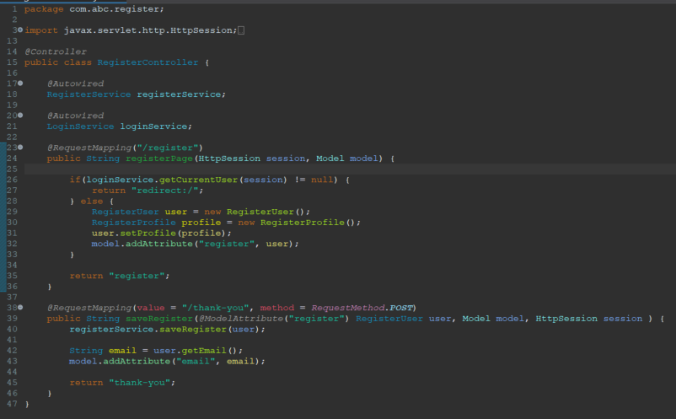
- Service
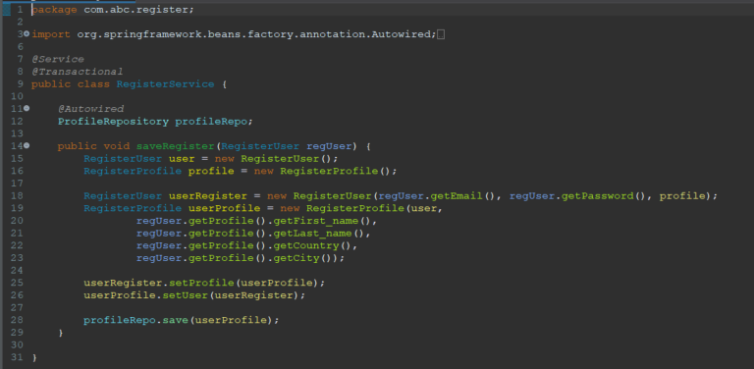
- Repository
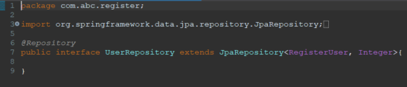
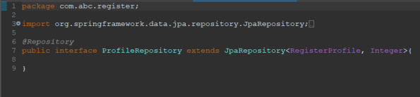

- Entity
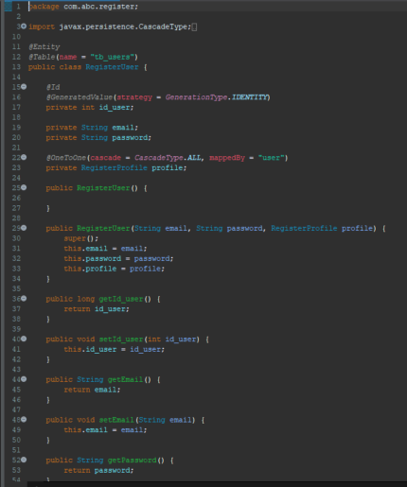
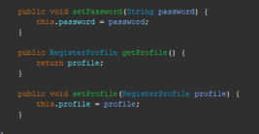
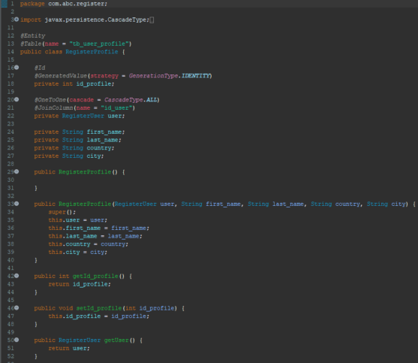
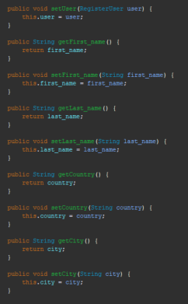

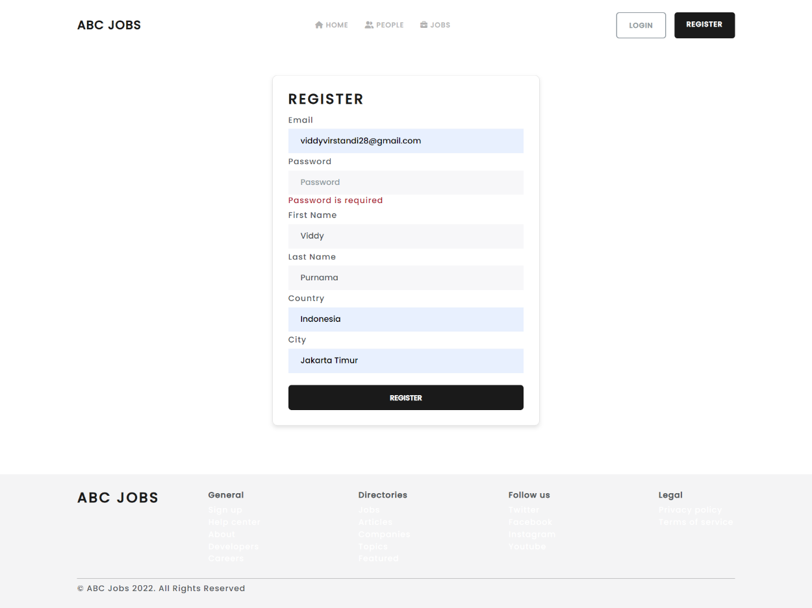

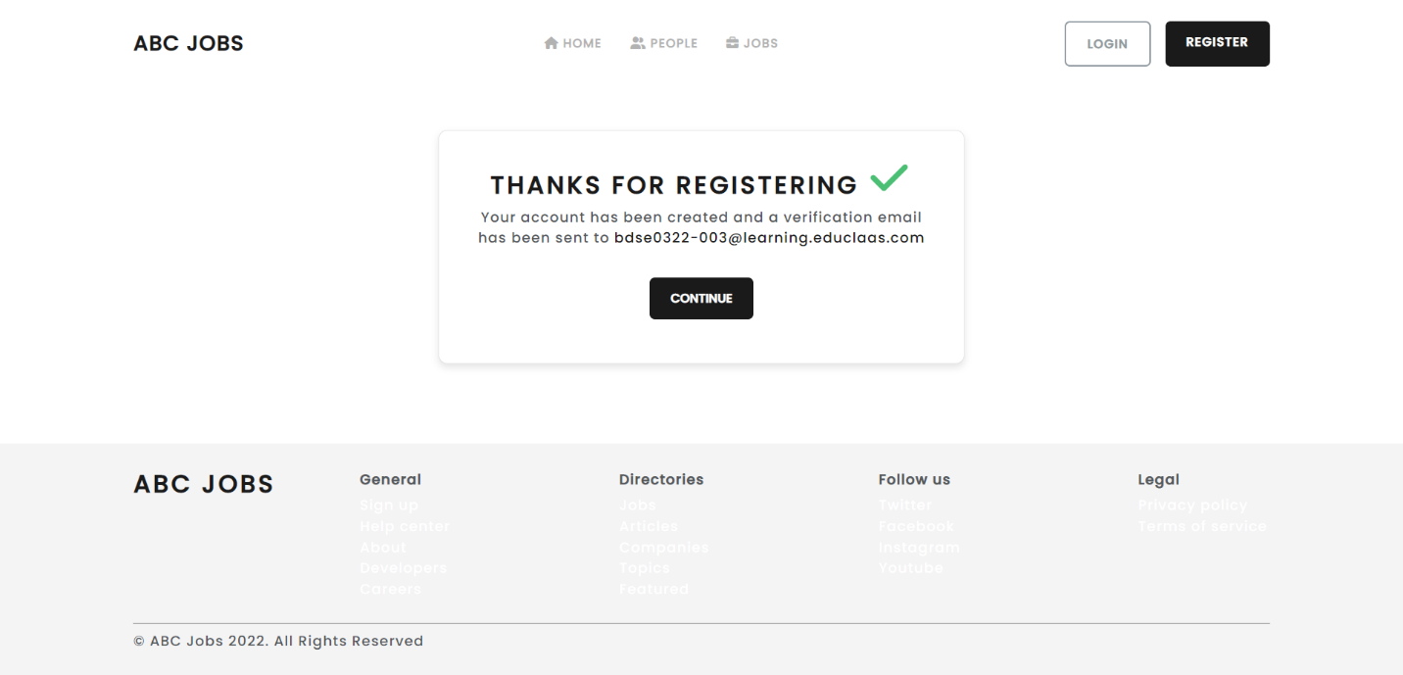

- Create update profile page
- Controller
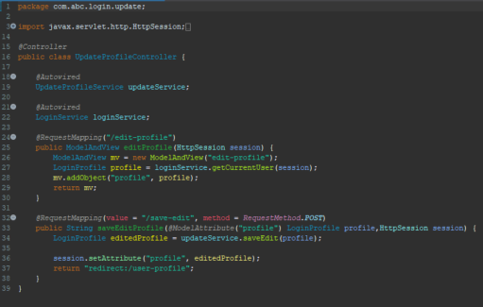

- Service
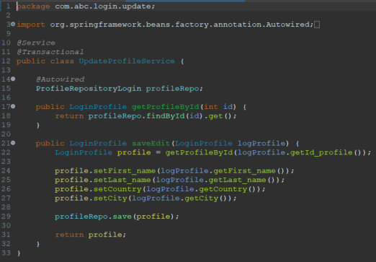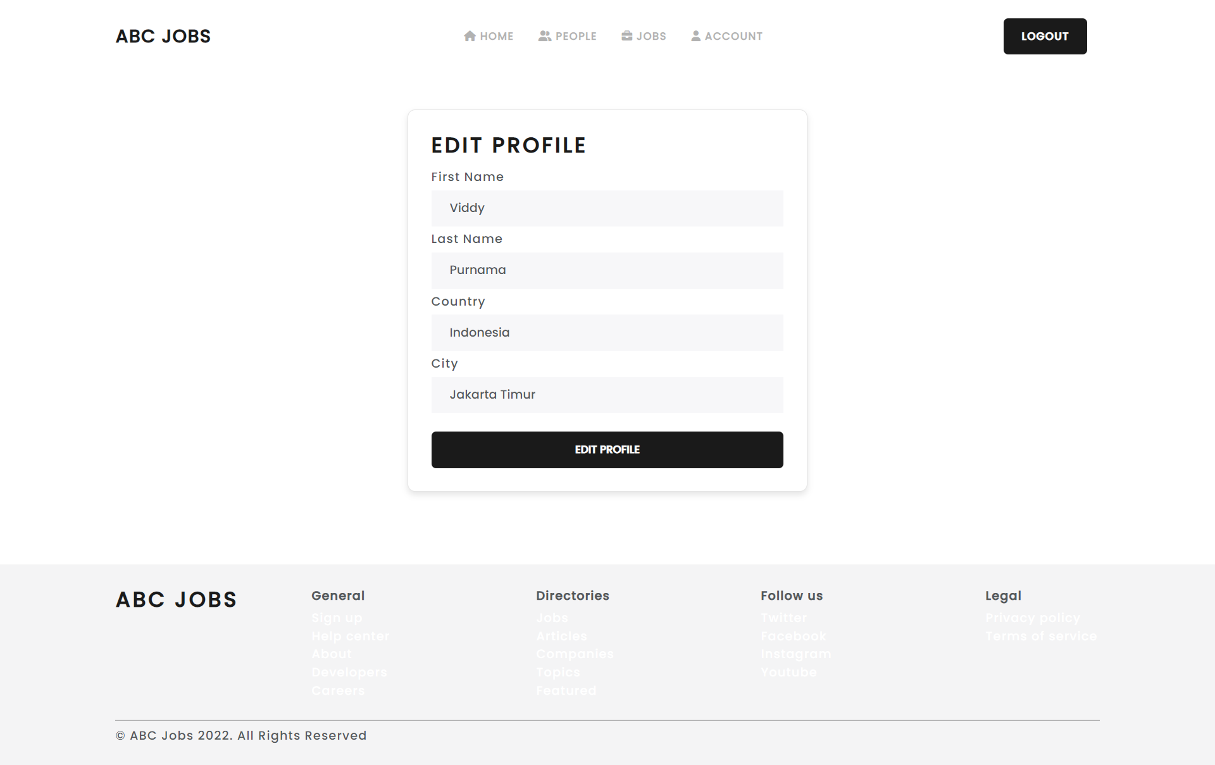

- Create the login system
- Controller
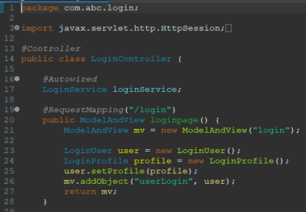

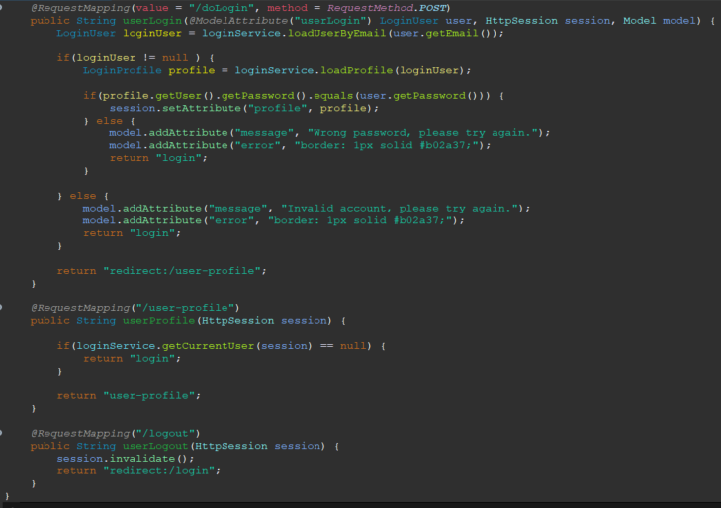

- Service
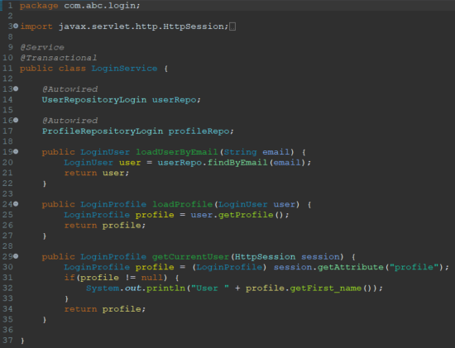

- Repository
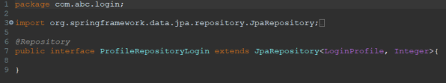

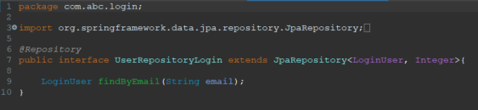

- Entity
